UNITED STATES
SECURITIES AND EXCHANGE COMMISSION
Washington, D.C. 20549
FORM |  |  | 8-K
CURRENT REPORT
Pursuant to Section 13 or 15(d)
of the Securities Exchange Act of 1934

Date of Report (Date of earliest event reported): September 8, 2026
X4 PHARMACEUTICALS, INC.
(Exact name of registrant as specified in its charter)
Delaware |  |  |  |  |  | 001-38295 |  |  |  |  |  | 27-3181608
(State or other jurisdiction of incorporation) |  |  |  |  |  | (Commission File Number) |  |  |  |  |  | (IRS Employer Identification No.)
61 North Beacon Street, |  |  | 4th Floor
Boston, |  |  | Massachusetts |  |  |  |  |  | 02134
(Address of principal executive offices) |  |  |  |  |  |  |  |  | (Zip Code)

(857) 529-8300
(Registrant’s telephone number, including area code)

Not applicable
(Former name or former address, if changed since last report)
_______________________________________________________________________________________________________
Check the appropriate box below if the Form 8-K filing is intended to simultaneously satisfy the filing obligation of the registrant under any of the following provisions:

☐ Written communications pursuant to Rule 425 under the Securities Act (17 CFR 230.425)
☐ Soliciting material pursuant to Rule 14a-12 under the Exchange Act (17 CFR 240.14a-12)
☐ Pre-commencement communications pursuant to Rule 14d-2(b) under the Exchange Act (17 CFR 240.14d-2(b))
☐ Pre-commencement communications pursuant to Rule 13e-4(c) under the Exchange Act (17 CFR 240.13e-4(c))

Securities registered pursuant to Section 12(b) of the Act:
Title of each class |  |  |  |  |  | Trading Symbol(s) |  |  |  |  |  | Name of each exchange on which registered
Common stock, par value $0.001 per share |  |  |  |  |  | XFOR |  |  |  |  |  | The Nasdaq Stock Market LLC

Indicate by check mark whether the registrant is an emerging growth company as defined in Rule 405 of the Securities Act of 1933 or Rule 12b-2 of the Securities Exchange Act of 1934.

Emerging growth company ☐

If an emerging growth company, indicate by check mark if the registrant has elected not to use the extended transition period for complying with any new or revised financial accounting standards provided pursuant to Section 13(a) of the Exchange Act. ☐

Item 8.01. |  |  | Other Events.
On September 8, 2026, X4 Pharmaceuticals, Inc. (the “Company”) posted an updated corporate presentation on the Company’s website. A copy of the presentation is filed as Exhibit 99.1 to this Current Report on Form 8-K and is incorporated by reference herein. To access the presentation, investors should visit the “Investors” section of the Company’s website at www.x4pharma.com.

Item 9.01. |  |  | Financial Statements and Exhibits.
(d) Exhibits. The following exhibits are being filed herewith:

Exhibit Number |  |  |  |  |  | Exhibit Title or Description
99.1 |  |  |  |  |  | Corporate Presentation, dated September 8, 2026
104 |  |  |  |  |  | Cover Page Interactive Data File (embedded within the Inline XBRL document)

SIGNATURE

Pursuant to the requirements of the Securities Exchange Act of 1934, the registrant has duly caused this report to be signed on its behalf by the undersigned hereunto duly authorized.

 |  |  |  |  |  | X4 PHARMACEUTICALS, INC.
 |  |  |  |  |  | By: |  |  | /s/ David Kirske
 |  |  |  |  |  |  |  |  | David Kirske
Date: September 8, 2026 |  |  |  |  |  |  |  |  | Chief Financial Officer and Treasurer



Corporate Presentation September 2026 Nasdaq: XFOR EXHIBIT 99.1

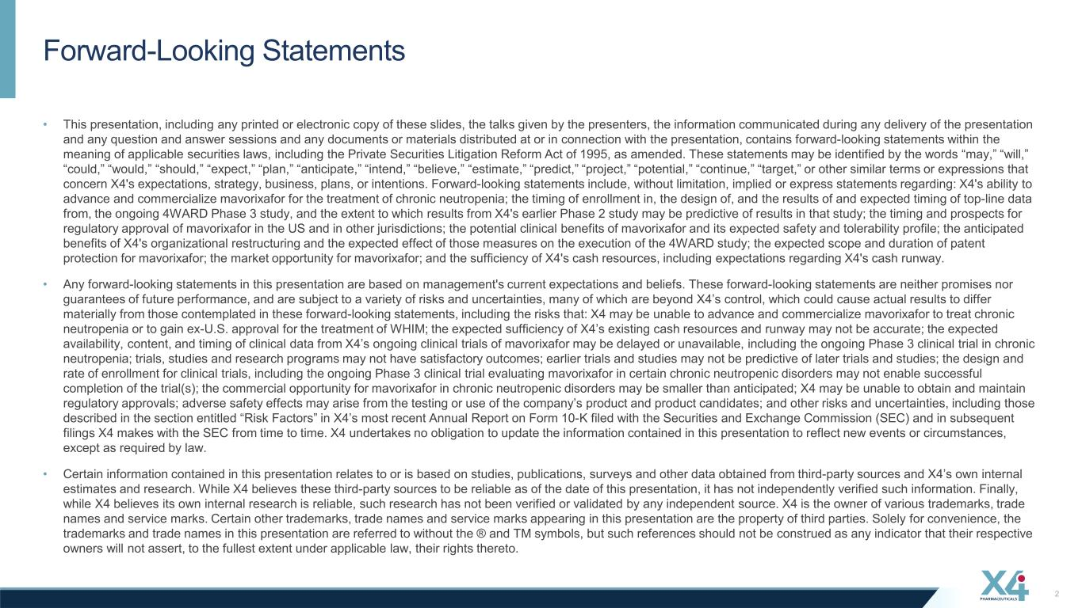
Forward-Looking Statements 2 • This presentation, including any printed or electronic copy of these slides, the talks given by the presenters, the information communicated during any delivery of the presentation and any question and answer sessions and any documents or materials distributed at or in connection with the presentation, contains forward-looking statements within the meaning of applicable securities laws, including the Private Securities Litigation Reform Act of 1995, as amended. These statements may be identified by the words “may,” “will,” “could,” “would,” “should,” “expect,” “plan,” “anticipate,” “intend,” “believe,” “estimate,” “predict,” “project,” “potential,” “continue,” “target,” or other similar terms or expressions that concern X4's expectations, strategy, business, plans, or intentions. Forward-looking statements include, without limitation, implied or express statements regarding: X4's ability to advance and commercialize mavorixafor for the treatment of chronic neutropenia; the timing of enrollment in, the design of, and the results of and expected timing of top-line data from, the ongoing 4WARD Phase 3 study, and the extent to which results from X4's earlier Phase 2 study may be predictive of results in that study; the timing and prospects for regulatory approval of mavorixafor in the US and in other jurisdictions; the potential clinical benefits of mavorixafor and its expected safety and tolerability profile; the anticipated benefits of X4's organizational restructuring and the expected effect of those measures on the execution of the 4WARD study; the expected scope and duration of patent protection for mavorixafor; the market opportunity for mavorixafor; and the sufficiency of X4's cash resources, including expectations regarding X4's cash runway. • Any forward-looking statements in this presentation are based on management's current expectations and beliefs. These forward-looking statements are neither promises nor guarantees of future performance, and are subject to a variety of risks and uncertainties, many of which are beyond X4’s control, which could cause actual results to differ materially from those contemplated in these forward-looking statements, including the risks that: X4 may be unable to advance and commercialize mavorixafor to treat chronic neutropenia or to gain ex-U.S. approval for the treatment of WHIM; the expected sufficiency of X4’s existing cash resources and runway may not be accurate; the expected availability, content, and timing of clinical data from X4’s ongoing clinical trials of mavorixafor may be delayed or unavailable, including the ongoing Phase 3 clinical trial in chronic neutropenia; trials, studies and research programs may not have satisfactory outcomes; earlier trials and studies may not be predictive of later trials and studies; the design and rate of enrollment for clinical trials, including the ongoing Phase 3 clinical trial evaluating mavorixafor in certain chronic neutropenic disorders may not enable successful completion of the trial(s); the commercial opportunity for mavorixafor in chronic neutropenic disorders may be smaller than anticipated; X4 may be unable to obtain and maintain regulatory approvals; adverse safety effects may arise from the testing or use of the company’s product and product candidates; and other risks and uncertainties, including those described in the section entitled “Risk Factors” in X4’s most recent Annual Report on Form 10-K filed with the Securities and Exchange Commission (SEC) and in subsequent filings X4 makes with the SEC from time to time. X4 undertakes no obligation to update the information contained in this presentation to reflect new events or circumstances, except as required by law. • Certain information contained in this presentation relates to or is based on studies, publications, surveys and other data obtained from third-party sources and X4’s own internal estimates and research. While X4 believes these third-party sources to be reliable as of the date of this presentation, it has not independently verified such information. Finally, while X4 believes its own internal research is reliable, such research has not been verified or validated by any independent source. X4 is the owner of various trademarks, trade names and service marks. Certain other trademarks, trade names and service marks appearing in this presentation are the property of third parties. Solely for convenience, the trademarks and trade names in this presentation are referred to without the ® and TM symbols, but such references should not be construed as any indicator that their respective owners will not assert, to the fullest extent under applicable law, their rights thereto.

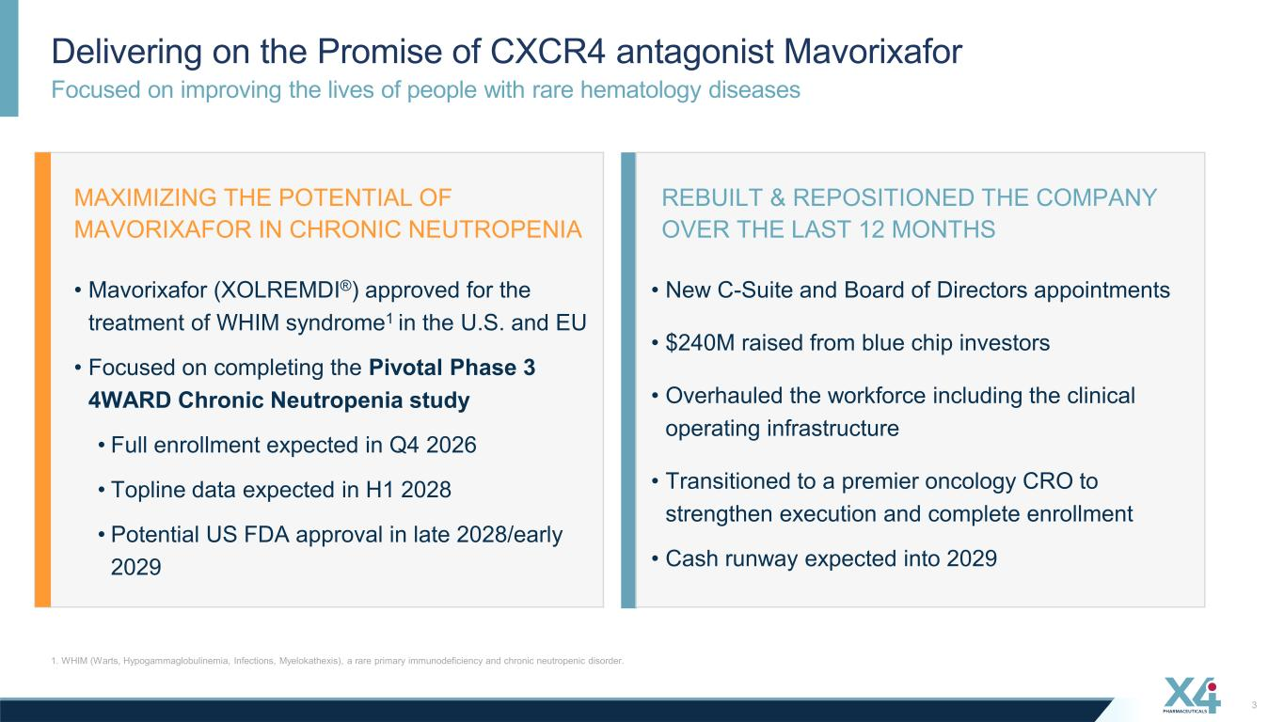
Focused on improving the lives of people with rare hematology diseases Delivering on the Promise of CXCR4 antagonist Mavorixafor 1. WHIM (Warts, Hypogammaglobulinemia, Infections, Myelokathexis), a rare primary immunodeficiency and chronic neutropenic disorder. 3 • Mavorixafor (XOLREMDI®) approved for the treatment of WHIM syndrome1 in the U.S. and EU • Focused on completing the Pivotal Phase 3 4WARD Chronic Neutropenia study • Full enrollment expected in Q4 2026 • Topline data expected in H1 2028 • Potential US FDA approval in late 2028/early 2029 MAXIMIZING THE POTENTIAL OF MAVORIXAFOR IN CHRONIC NEUTROPENIA REBUILT & REPOSITIONED THE COMPANY OVER THE LAST 12 MONTHS • New C-Suite and Board of Directors appointments • $240M raised from blue chip investors • Overhauled the workforce including the clinical operating infrastructure • Transitioned to a premier oncology CRO to strengthen execution and complete enrollment • Cash runway expected into 2029

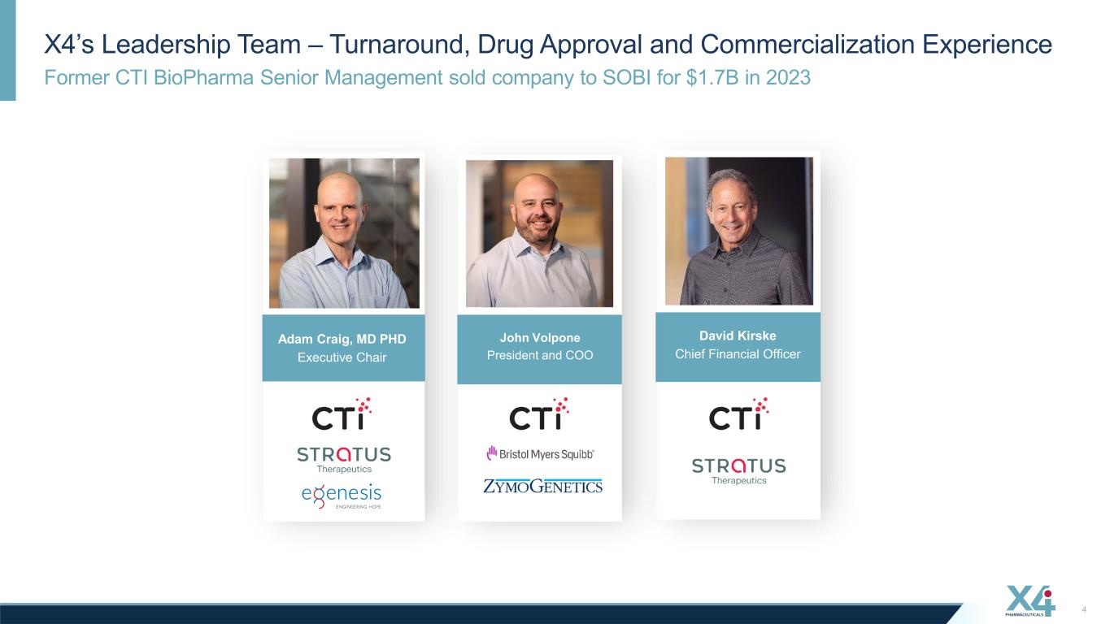
Former CTI BioPharma Senior Management sold company to SOBI for $1.7B in 2023 X4’s Leadership Team – Turnaround, Drug Approval and Commercialization Experience 4 cDavid Kirske Chief Financial Officer cAdam Craig, MD PHD Executive Chair cJohn Volpone President and COO

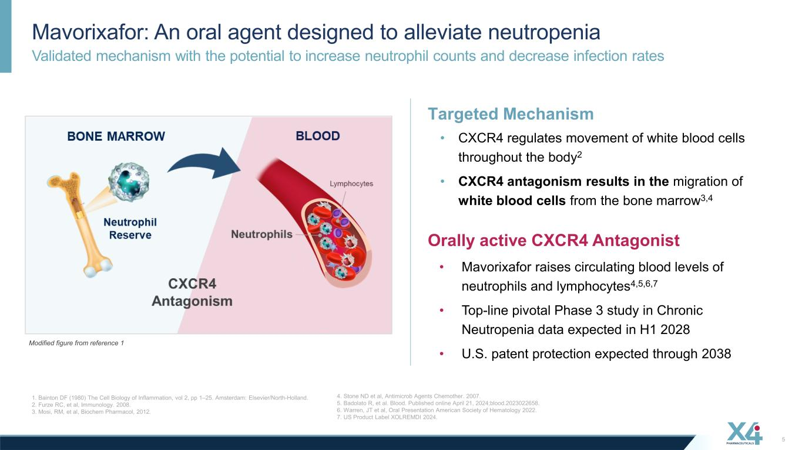
Validated mechanism with the potential to increase neutrophil counts and decrease infection rates Mavorixafor: An oral agent designed to alleviate neutropenia 1. Bainton DF (1980) The Cell Biology of Inflammation, vol 2, pp 1–25. Amsterdam: Elsevier/North-Holland. 2. Furze RC, et al, Immunology. 2008. 3. Mosi, RM, et al, Biochem Pharmacol, 2012. 5 Targeted Mechanism • CXCR4 regulates movement of white blood cells throughout the body2 • CXCR4 antagonism results in the migration of white blood cells from the bone marrow3,4 Modified figure from reference 1 Orally active CXCR4 Antagonist • Mavorixafor raises circulating blood levels of neutrophils and lymphocytes4,5,6,7 • Top-line pivotal Phase 3 study in Chronic Neutropenia data expected in H1 2028 • U.S. patent protection expected through 2038 4. Stone ND et al, Antimicrob Agents Chemother. 2007. 5. Badolato R, et al. Blood. Published online April 21, 2024;blood.2023022658. 6. Warren, JT et al, Oral Presentation American Society of Hematology 2022. 7. US Product Label XOLREMDI 2024.

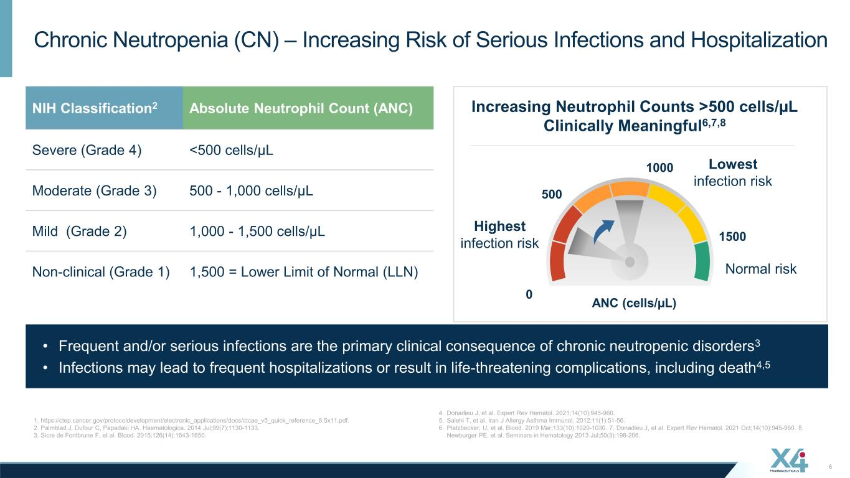
Chronic Neutropenia (CN) – Increasing Risk of Serious Infections and Hospitalization 1. https://ctep.cancer.gov/protocoldevelopment/electronic_applications/docs/ctcae_v5_quick_reference_8.5x11.pdf. 2. Palmblad J, Dufour C, Papadaki HA. Haematologica. 2014 Jul;99(7):1130-1133. 3. Sicre de Fontbrune F, et al. Blood. 2015;126(14):1643-1650. 6 • Frequent and/or serious infections are the primary clinical consequence of chronic neutropenic disorders3 • Infections may lead to frequent hospitalizations or result in life-threatening complications, including death4,5 NIH Classification2 Absolute Neutrophil Count (ANC) Severe (Grade 4) <500 cells/µL Moderate (Grade 3) 500 - 1,000 cells/µL Mild (Grade 2) 1,000 - 1,500 cells/µL Non-clinical (Grade 1) 1,500 = Lower Limit of Normal (LLN) 1500 500 0 ANC (cells/µL) Increasing Neutrophil Counts >500 cells/µL Clinically Meaningful6,7,8 Highest infection risk Lowest infection risk 1000 Normal risk 4. Donadieu J, et al. Expert Rev Hematol. 2021;14(10):945-960. 5. Salehi T, et al. Iran J Allergy Asthma Immunol. 2012;11(1):51-56. 6. Platzbecker, U, et al. Blood. 2019 Mar;133(10):1020-1030. 7. Donadieu J, et al. Expert Rev Hematol. 2021 Oct;14(10):945-960. 8. Newburger PE, et al. Seminars in Hematology 2013 Jul;50(3):198-206.

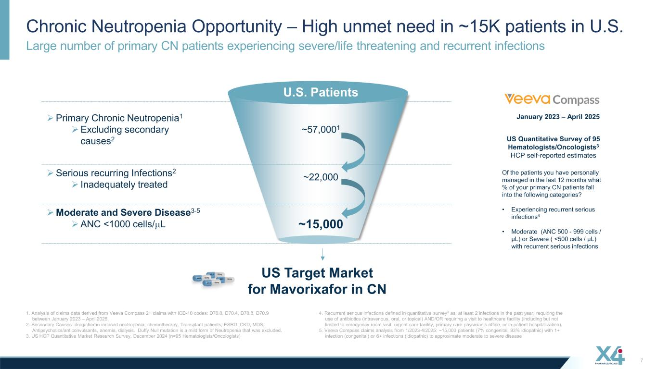
Large number of primary CN patients experiencing severe/life threatening and recurrent infections Chronic Neutropenia Opportunity – High unmet need in ~15K patients in U.S. 1. Analysis of claims data derived from Veeva Compass 2+ claims with ICD-10 codes: D70.0, D70.4, D70.8, D70.9 between January 2023 – April 2025. 2. Secondary Causes: drug/chemo induced neutropenia, chemotherapy, Transplant patients, ESRD, CKD, MDS, Antipsychotics/anticonvulsants, anemia, dialysis. Duffy Null mutation is a mild form of Neutropenia that was excluded. 3. US HCP Quantitative Market Research Survey, December 2024 (n=95 Hematologists/Oncologists) 7 U.S. Patients ➢Primary Chronic Neutropenia1 ➢Excluding secondary causes2 ~57,0001 ➢Serious recurring Infections2 ➢ Inadequately treated ~22,000 ➢Moderate and Severe Disease3-5 ➢ANC <1000 cells/µL ~15,000 US Target Market for Mavorixafor in CN January 2023 – April 2025 Of the patients you have personally managed in the last 12 months what % of your primary CN patients fall into the following categories? • Experiencing recurrent serious infections4 • Moderate (ANC 500 - 999 cells / µL) or Severe ( <500 cells / µL) with recurrent serious infections US Quantitative Survey of 95 Hematologists/Oncologists3 HCP self-reported estimates 4. Recurrent serious infections defined in quantitative survey3 as: at least 2 infections in the past year, requiring the use of antibiotics (intravenous, oral, or topical) AND/OR requiring a visit to healthcare facility (including but not limited to emergency room visit, urgent care facility, primary care physician’s office, or in-patient hospitalization). 5. Veeva Compass claims analysis from 1/2023-4/2025: ~15,000 patients (7% congenital, 93% idiopathic) with 1+ infection (congenital) or 6+ infections (idiopathic) to approximate moderate to severe disease

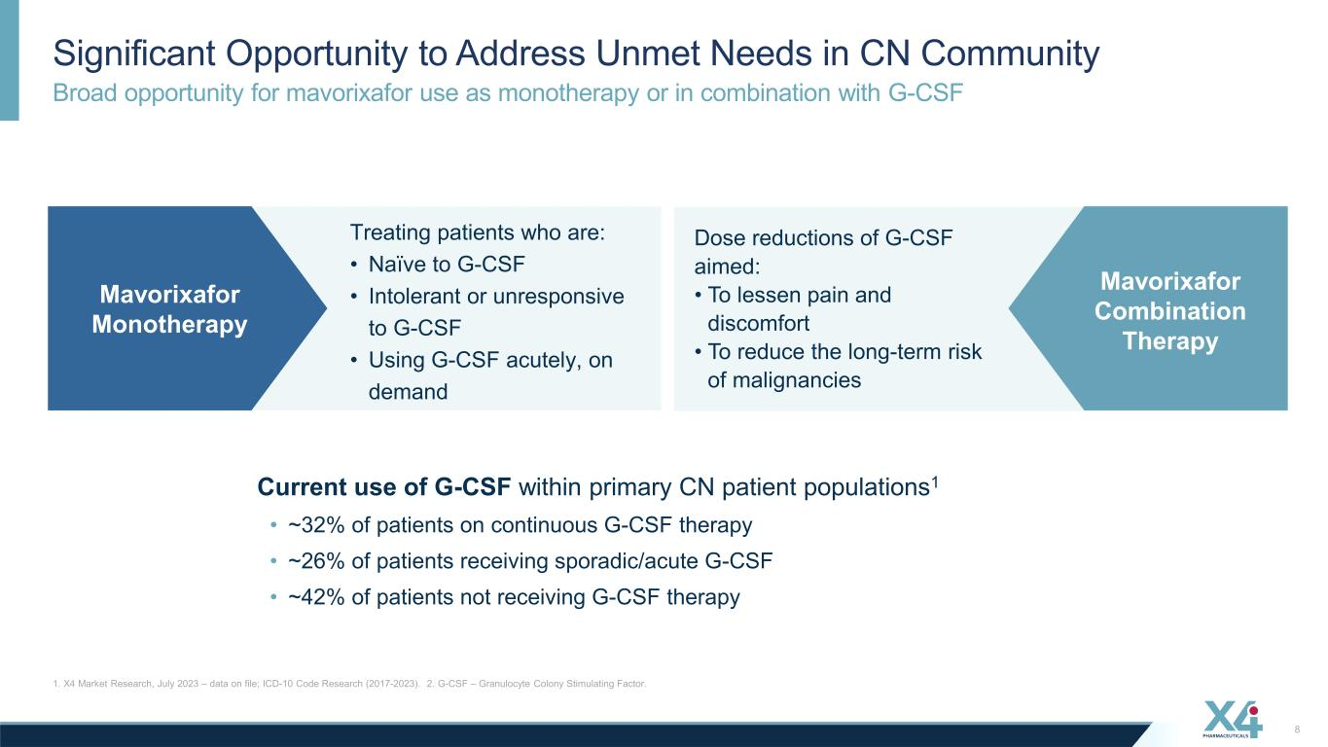
Broad opportunity for mavorixafor use as monotherapy or in combination with G-CSF Significant Opportunity to Address Unmet Needs in CN Community 1. X4 Market Research, July 2023 – data on file; ICD-10 Code Research (2017-2023). 2. G-CSF – Granulocyte Colony Stimulating Factor. 8 Current use of G-CSF within primary CN patient populations1 • ~32% of patients on continuous G-CSF therapy • ~26% of patients receiving sporadic/acute G-CSF • ~42% of patients not receiving G-CSF therapy Mavorixafor Monotherapy Treating patients who are: • Naïve to G-CSF • Intolerant or unresponsive to G-CSF • Using G-CSF acutely, on demand Dose reductions of G-CSF aimed: • To lessen pain and discomfort • To reduce the long-term risk of malignancies Mavorixafor Combination Therapy

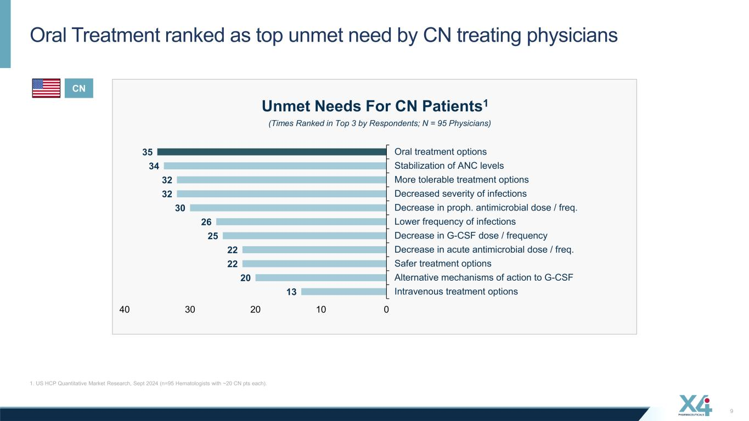
13 20 22 22 25 26 30 32 32 34 35 Intravenous treatment options Alternative mechanisms of action to G-CSF Safer treatment options Decrease in acute antimicrobial dose / freq. Decrease in G-CSF dose / frequency Lower frequency of infections Decrease in proph. antimicrobial dose / freq. Decreased severity of infections More tolerable treatment options Stabilization of ANC levels Oral treatment options 010203040 Oral Treatment ranked as top unmet need by CN treating physicians 1. US HCP Quantitative Market Research, Sept 2024 (n=95 Hematologists with ~20 CN pts each). 9 Unmet Needs For CN Patients1 (Times Ranked in Top 3 by Respondents; N = 95 Physicians) CN

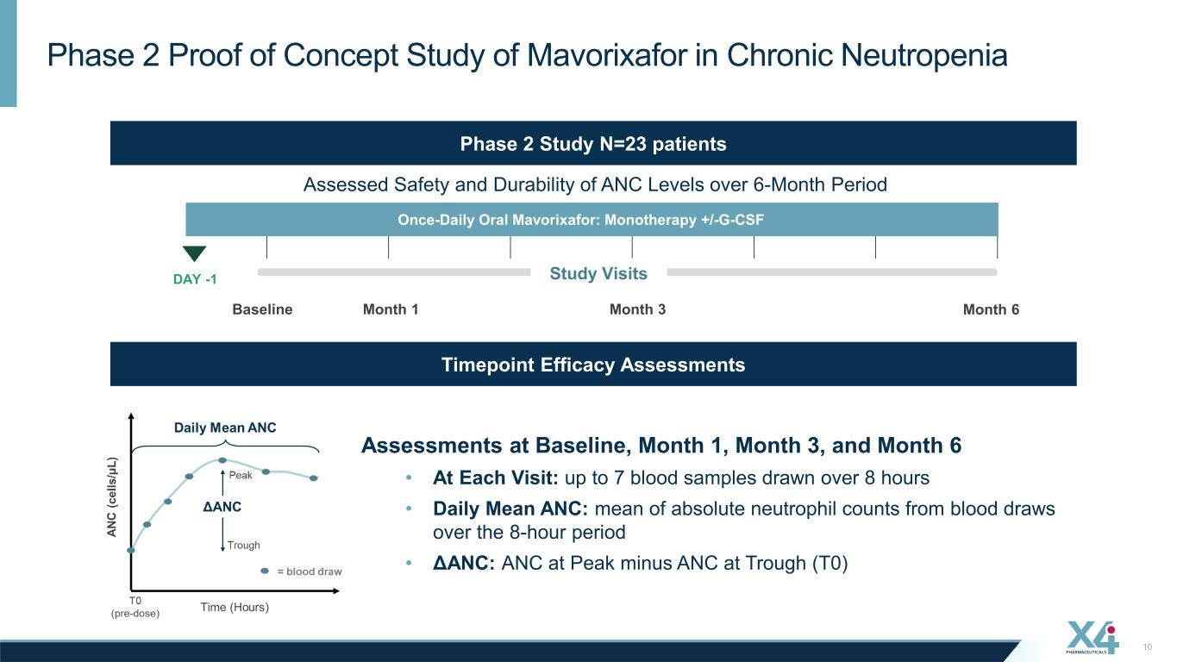
10 Phase 2 Proof of Concept Study of Mavorixafor in Chronic Neutropenia Phase 2 Study N=23 patients Baseline Assessed Safety and Durability of ANC Levels over 6-Month Period Once-Daily Oral Mavorixafor: Monotherapy +/-G-CSF DAY -1 Month 1 Month 3 Month 6 Study Visits Assessments at Baseline, Month 1, Month 3, and Month 6 • At Each Visit: up to 7 blood samples drawn over 8 hours • Daily Mean ANC: mean of absolute neutrophil counts from blood draws over the 8-hour period • ΔANC: ANC at Peak minus ANC at Trough (T0) Timepoint Efficacy Assessments

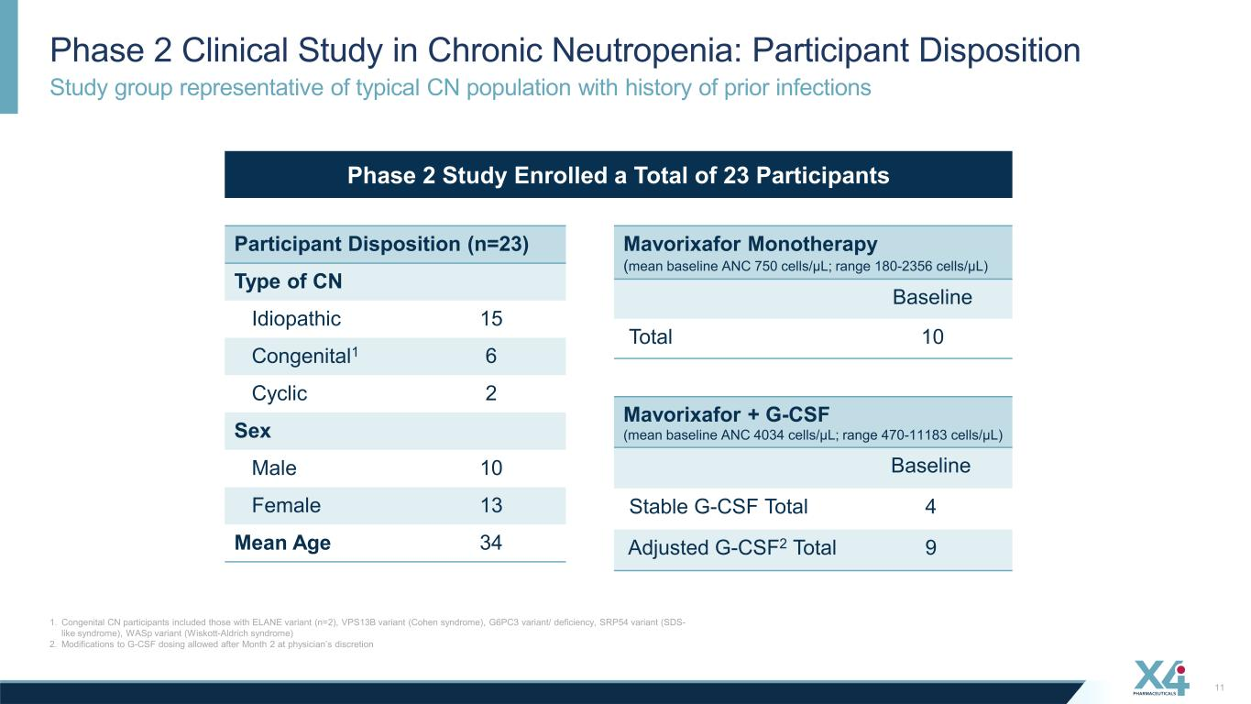
Study group representative of typical CN population with history of prior infections Phase 2 Clinical Study in Chronic Neutropenia: Participant Disposition 1. Congenital CN participants included those with ELANE variant (n=2), VPS13B variant (Cohen syndrome), G6PC3 variant/ deficiency, SRP54 variant (SDS- like syndrome), WASp variant (Wiskott-Aldrich syndrome) 2. Modifications to G-CSF dosing allowed after Month 2 at physician’s discretion 11 Participant Disposition (n=23) Type of CN Idiopathic 15 Congenital1 6 Cyclic 2 Sex Male 10 Female 13 Mean Age 34 Mavorixafor + G-CSF (mean baseline ANC 4034 cells/µL; range 470-11183 cells/µL) Baseline Stable G-CSF Total 4 Adjusted G-CSF2 Total 9 Mavorixafor Monotherapy (mean baseline ANC 750 cells/µL; range 180-2356 cells/µL) Baseline Total 10 Phase 2 Study Enrolled a Total of 23 Participants

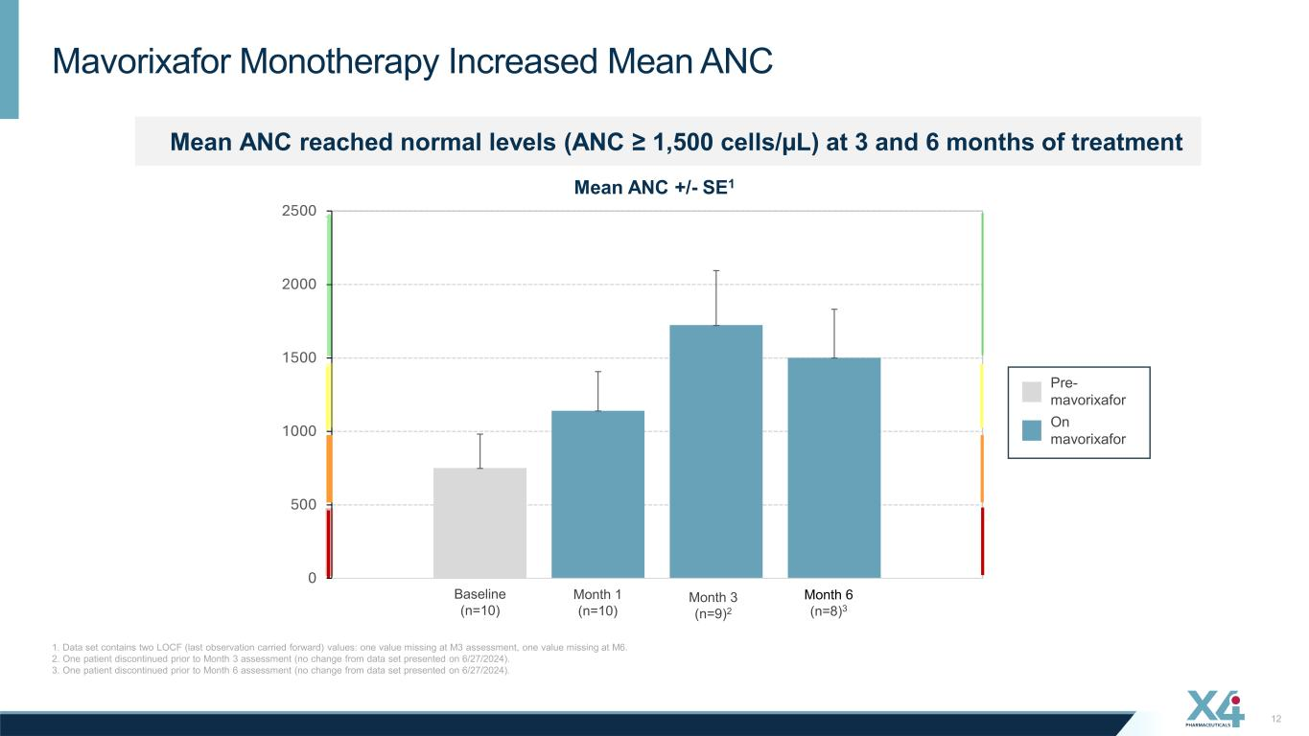
Mavorixafor Monotherapy Increased Mean ANC 1. Data set contains two LOCF (last observation carried forward) values: one value missing at M3 assessment, one value missing at M6. 2. One patient discontinued prior to Month 3 assessment (no change from data set presented on 6/27/2024). 3. One patient discontinued prior to Month 6 assessment (no change from data set presented on 6/27/2024). 12 Mean ANC reached normal levels (ANC ≥ 1,500 cells/µL) at 3 and 6 months of treatment Pre- mavorixafor On mavorixafor 0 500 1000 1500 2000 2500 Mean Mean ANC +/- SE1 Month 3 (n=9)2 Month 6 (n=8)3 Month 1 (n=10) Baseline (n=10)

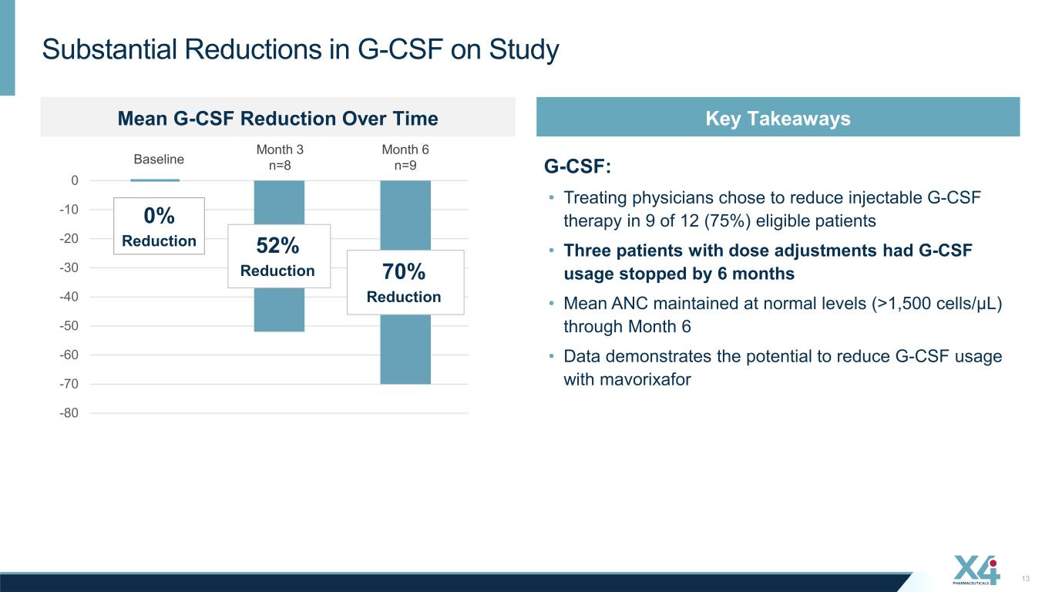
13 Substantial Reductions in G-CSF on Study G-CSF: • Treating physicians chose to reduce injectable G-CSF therapy in 9 of 12 (75%) eligible patients • Three patients with dose adjustments had G-CSF usage stopped by 6 months • Mean ANC maintained at normal levels (>1,500 cells/µL) through Month 6 • Data demonstrates the potential to reduce G-CSF usage with mavorixafor 52% Reduction 70% Reduction -80 -70 -60 -50 -40 -30 -20 -10 0 Month 3 n=8 Month 6 n=9Baseline 0% Reduction Key TakeawaysMean G-CSF Reduction Over Time

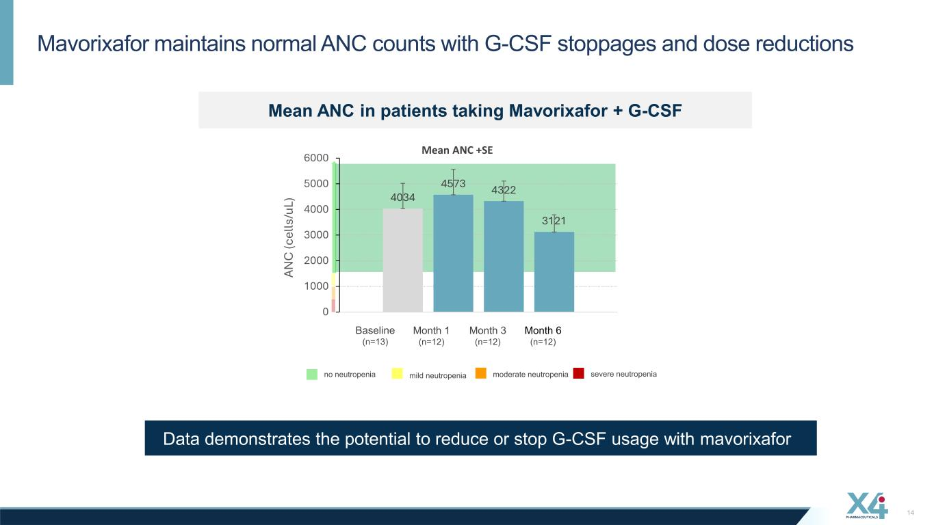
Mavorixafor maintains normal ANC counts with G-CSF stoppages and dose reductions 14 Data demonstrates the potential to reduce or stop G-CSF usage with mavorixafor no neutropenia mild neutropenia moderate neutropenia severe neutropenia Month 3 (n=12) Month 6 (n=12) Month 1 (n=12) Baseline (n=13) 4034 4573 4322 3121 0 1000 2000 3000 4000 5000 6000 Mean AN C (c el ls /u L) Mean ANC in patients taking Mavorixafor + G-CSF Mean ANC +SE

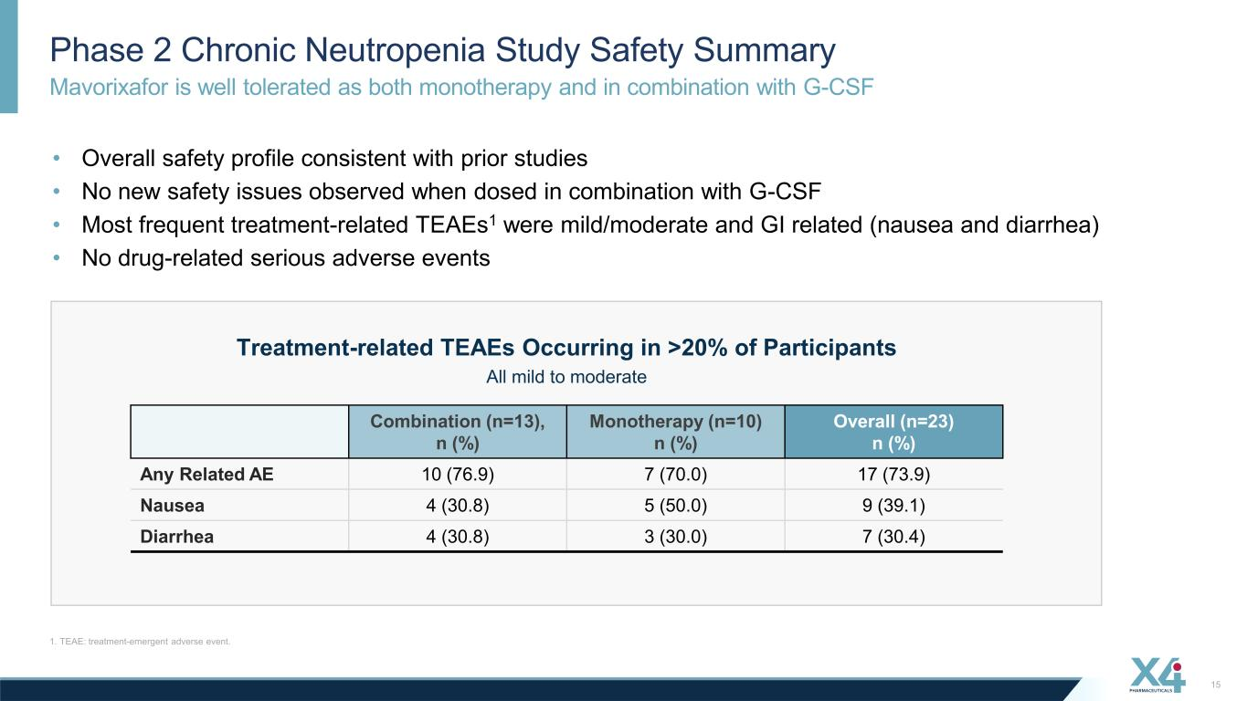
Mavorixafor is well tolerated as both monotherapy and in combination with G-CSF Phase 2 Chronic Neutropenia Study Safety Summary 1. TEAE: treatment-emergent adverse event. 15 Combination (n=13), n (%) Monotherapy (n=10) n (%) Overall (n=23) n (%) Any Related AE 10 (76.9) 7 (70.0) 17 (73.9) Nausea 4 (30.8) 5 (50.0) 9 (39.1) Diarrhea 4 (30.8) 3 (30.0) 7 (30.4) Treatment-related TEAEs Occurring in >20% of Participants • Overall safety profile consistent with prior studies • No new safety issues observed when dosed in combination with G-CSF • Most frequent treatment-related TEAEs1 were mild/moderate and GI related (nausea and diarrhea) • No drug-related serious adverse events All mild to moderate

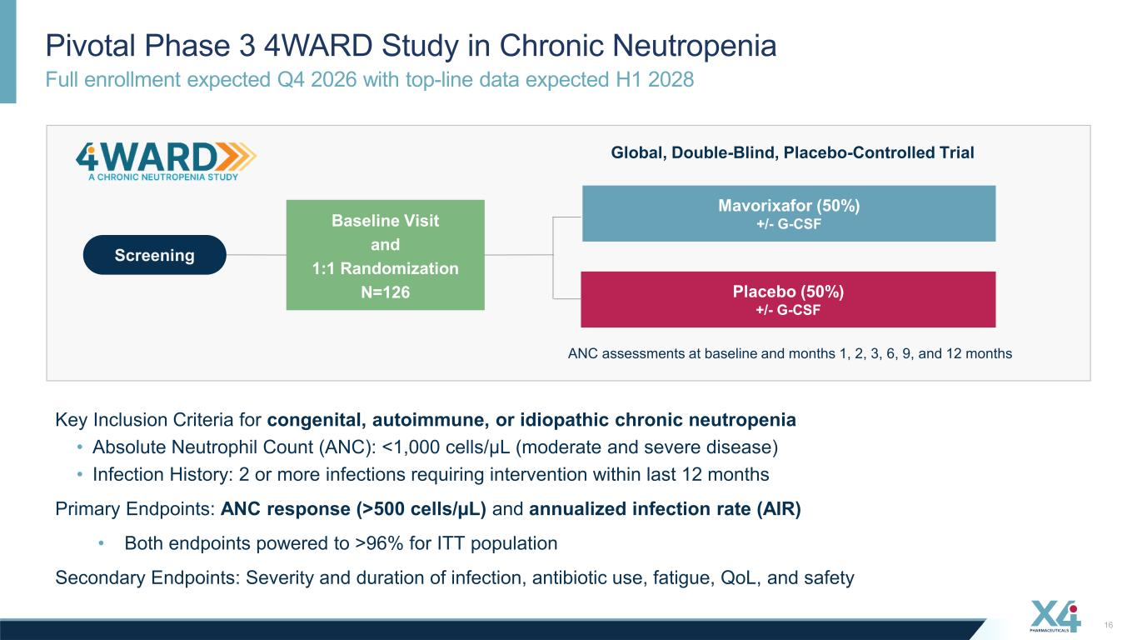
Full enrollment expected Q4 2026 with top-line data expected H1 2028 Pivotal Phase 3 4WARD Study in Chronic Neutropenia 16 Mavorixafor (50%) +/- G-CSF Placebo (50%) +/- G-CSF Global, Double-Blind, Placebo-Controlled Trial Screening Baseline Visit and 1:1 Randomization N=126 ANC assessments at baseline and months 1, 2, 3, 6, 9, and 12 months Key Inclusion Criteria for congenital, autoimmune, or idiopathic chronic neutropenia • Absolute Neutrophil Count (ANC): <1,000 cells/µL (moderate and severe disease) • Infection History: 2 or more infections requiring intervention within last 12 months Primary Endpoints: ANC response (>500 cells/µL) and annualized infection rate (AIR) • Both endpoints powered to >96% for ITT population Secondary Endpoints: Severity and duration of infection, antibiotic use, fatigue, QoL, and safety

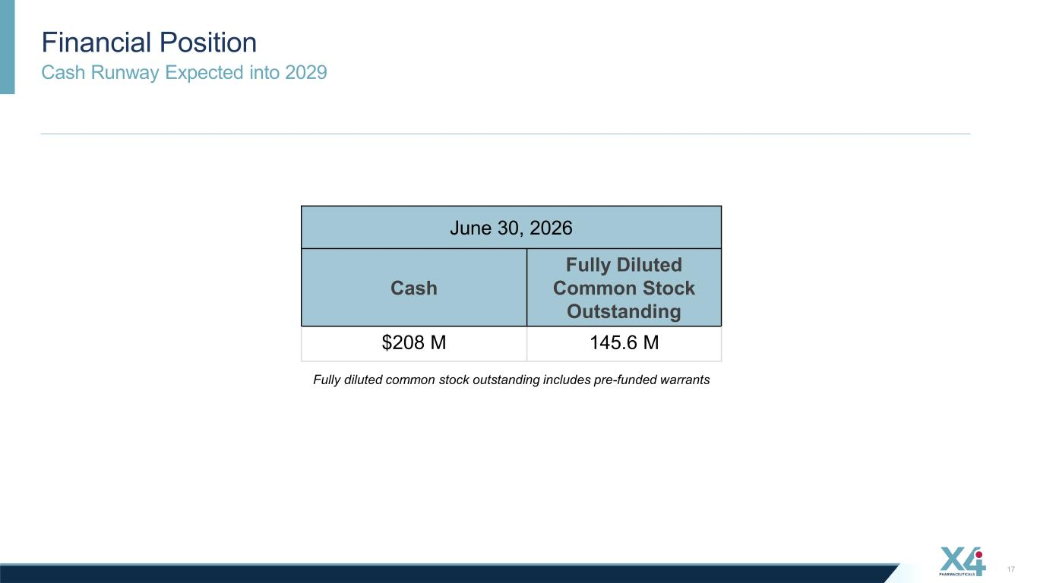
Cash Runway Expected into 2029 Financial Position 17 Fully diluted common stock outstanding includes pre-funded warrants June 30, 2026 Cash Fully Diluted Common Stock Outstanding $208 M 145.6 M

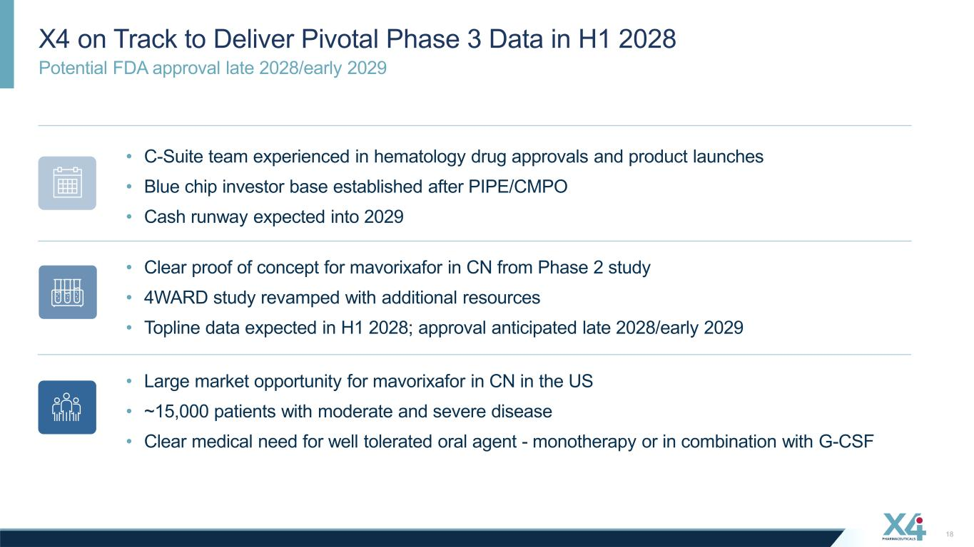
Potential FDA approval late 2028/early 2029 X4 on Track to Deliver Pivotal Phase 3 Data in H1 2028 18 • Large market opportunity for mavorixafor in CN in the US • ~15,000 patients with moderate and severe disease • Clear medical need for well tolerated oral agent - monotherapy or in combination with G-CSF • C-Suite team experienced in hematology drug approvals and product launches • Blue chip investor base established after PIPE/CMPO • Cash runway expected into 2029 • Clear proof of concept for mavorixafor in CN from Phase 2 study • 4WARD study revamped with additional resources • Topline data expected in H1 2028; approval anticipated late 2028/early 2029


Appendix

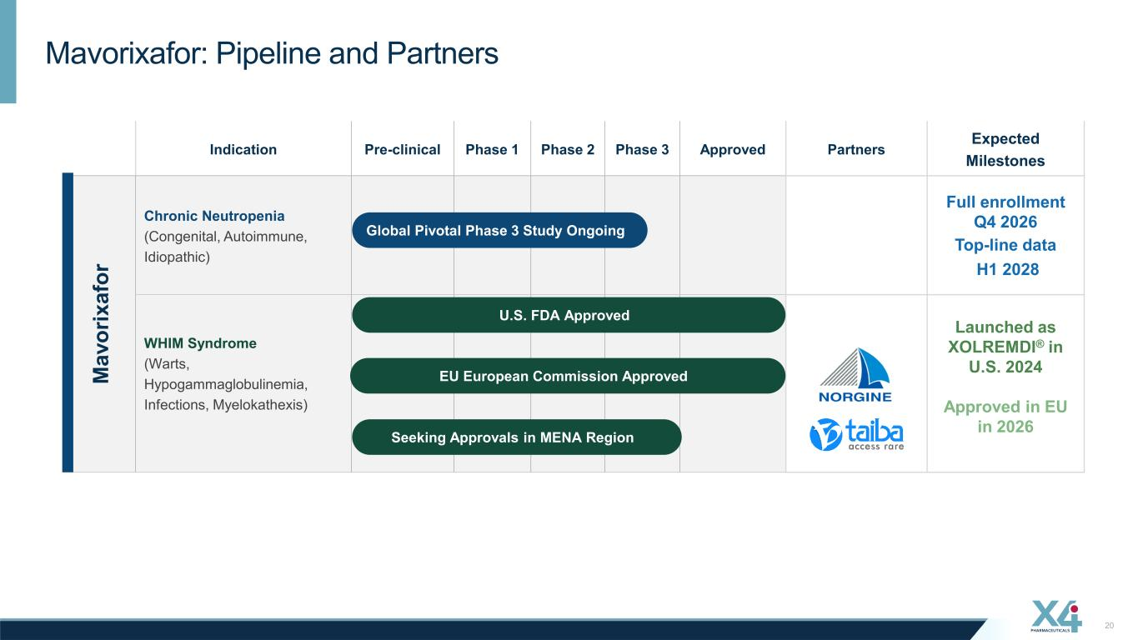
20 Mavorixafor: Pipeline and Partners Indication Pre-clinical Phase 1 Phase 2 Phase 3 Approved Partners Expected Milestones M av or ix af or Chronic Neutropenia (Congenital, Autoimmune, Idiopathic) Full enrollment Q4 2026 Top-line data H1 2028 WHIM Syndrome (Warts, Hypogammaglobulinemia, Infections, Myelokathexis) Launched as XOLREMDI® in U.S. 2024 Approved in EU in 2026 U.S. FDA Approved Global Pivotal Phase 3 Study Ongoing EU European Commission Approved Seeking Approvals in MENA Region

